Spearman rank correlation: GBPUSD and EURGBP
Method 02 / daily log returns / Alpari D1 full available history

Study setup
Logical pair: GBPUSD , EURGBP
Broker symbols: GBPUSD_i , EURGBP_i
Snapshot: 2026-11-03_majors_alpari_D1
Timeframe: D1
Matched return window: 1999-01-06 to 2026-11-02 (UTC bar dates)
Matched return count n: 7199
Dropped unfinished last bar dated 2026-11-03 UTC after a tick-volume check against the prior complete day.
Complete matched rows (CSV): GBPUSD-EURGBP_Spearman_D1.csv
Complete matched rows (HTML table): GBPUSD-EURGBP_Spearman_D1_data.html

Method carried forward
Spearman rho is Pearson correlation on the ranks of matched daily log returns of close, ln(close_t / close_t-1), in the broker quote direction. Ties use average ranks. Quotes are not inverted. rho is symmetric under swap of the two symbols. rho = 0 means no consistent rank-order link in this sample; it does not mean no link of any kind. The score is not a cause, not a lead, and not a trading signal. Daily rows are not independent draws, so the two-sided p-value and approximate Fisher interval are reported and treated as secondary to rho. Same-sample Pearson r is shown only as a side check; a large rho minus r gap can flag outliers or a non-straight link.

Results
Spearman rho: -0.317786
Two-sided p-value: 1.24764e-168
Approximate 95% Fisher interval: [-0.338402, -0.296864]
Same-sample Pearson r: -0.397845
rho minus r: 0.080059

Conclusion
Over 7199 matched daily log-return rows for GBPUSD and EURGBP (broker quote directions unchanged), Spearman rho is -0.3178 (negative, weak rank-order association in this sample). Approximate 95% Fisher interval: [-0.3384, -0.2969]. Same-sample Pearson r is -0.3978 (rho minus r = 0.0801). Two-sided p under the usual independent-ranks model is 1.248e-168; that model does not match linked daily FX returns, so treat p as secondary. This does not establish cause, lead-lag, or a lasting trading rule.

Charts
Daily closes

Daily log returns
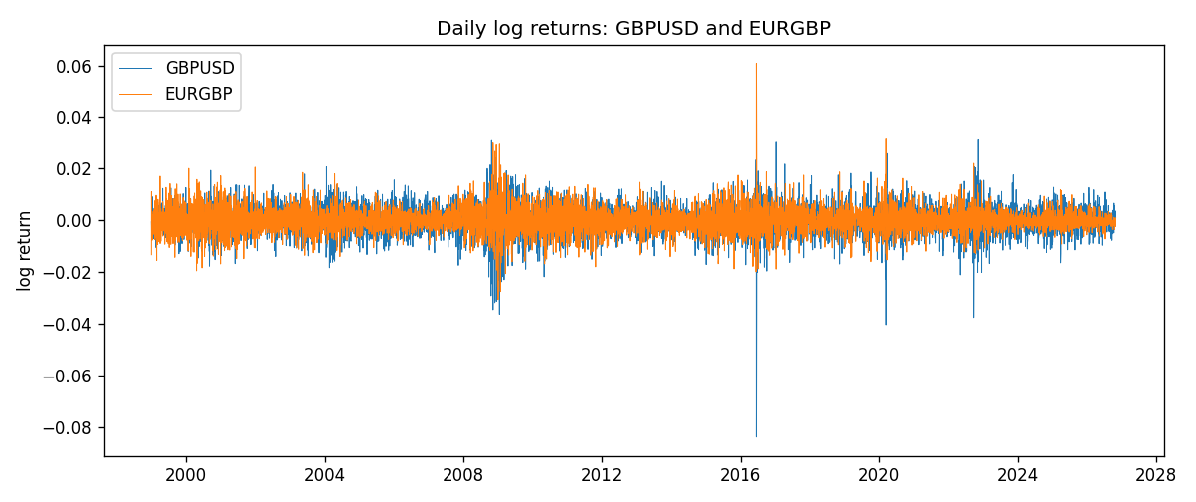
Log-return scatter
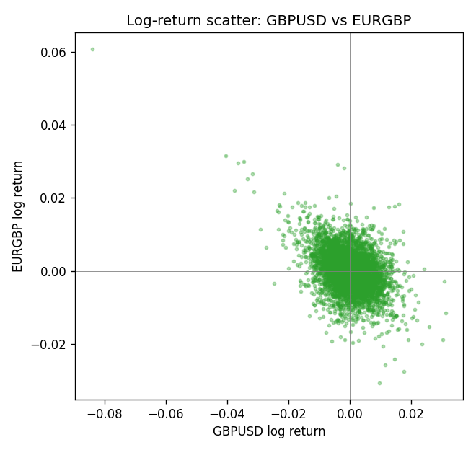
Rank-rank scatter
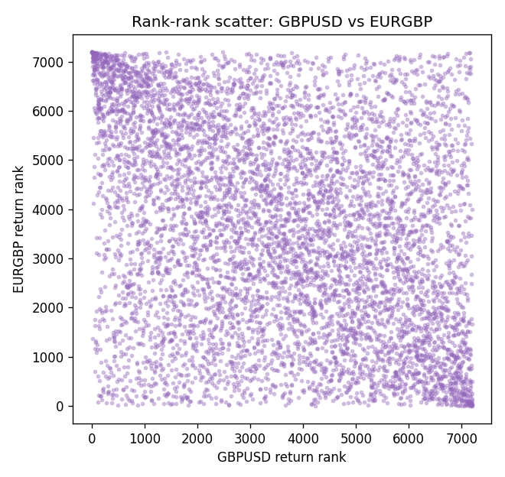

Data report
Every matched row that entered Spearman rho is stored in the sibling CSV named GBPUSD-EURGBP_Spearman_D1.csv. That file is the complete data archive for redrawing charts. Embedding all rows as a Word table is impractical at this length; the Word file holds the column list, column summaries, and the first and last 15 matched rows.
Columns: time, GBPUSD_open, EURGBP_open, GBPUSD_high, EURGBP_high, GBPUSD_low, EURGBP_low, GBPUSD_close, EURGBP_close, GBPUSD_tick_volume, EURGBP_tick_volume, GBPUSD_spread, EURGBP_spread, GBPUSD_real_volume, EURGBP_real_volume, GBPUSD_log_return, EURGBP_log_return
Column summaries (matched calculation rows)
column | count | mean | std | min | 25% | 50% | 75% | max
GBPUSD_open | 7199 | 1.5160931 | 0.21831499 | 1.06854 | 1.324955 | 1.5114 | 1.63186 | 2.1066
EURGBP_open | 7199 | 0.78665041 | 0.09676322 | 0.5734 | 0.6873 | 0.83367 | 0.865175 | 0.9769
GBPUSD_high | 7199 | 1.5223838 | 0.21887686 | 1.08366 | 1.32978 | 1.5181 | 1.6384 | 2.1161
EURGBP_high | 7199 | 0.78972718 | 0.09713886 | 0.5789 | 0.68935 | 0.83657 | 0.86804 | 0.9799
GBPUSD_low | 7199 | 1.5097628 | 0.21753729 | 1.03518 | 1.3194 | 1.50323 | 1.62442 | 2.0983
EURGBP_low | 7199 | 0.78395066 | 0.09658082 | 0.5682 | 0.6853 | 0.83147 | 0.862765 | 0.9661
GBPUSD_close | 7199 | 1.5161471 | 0.21826306 | 1.06879 | 1.325055 | 1.51122 | 1.63216 | 2.1065
EURGBP_close | 7199 | 0.78669405 | 0.09676312 | 0.5735 | 0.6875 | 0.8337 | 0.86528 | 0.977
GBPUSD_tick_volume | 7199 | 94850.986 | 153561.38 | 62 | 9998.5 | 52911 | 91818.5 | 1273370
EURGBP_tick_volume | 7199 | 86949.029 | 145390.09 | 154 | 6517.5 | 44265 | 81326 | 1424684
GBPUSD_spread | 7199 | 26.96055 | 19.19062 | 0 | 11 | 20 | 50 | 50
EURGBP_spread | 7199 | 21.393666 | 19.14328 | 0 | 4 | 13 | 50 | 50
GBPUSD_real_volume | 7199 | 3.5570778e+09 | 8.4449923e+10 | 0 | 0 | 0 | 0 | 2.4038164e+12
EURGBP_real_volume | 7199 | 2.7805214e+10 | 1.3507095e+11 | 0 | 0 | 0 | 0 | 3.5726265e+12
GBPUSD_log_return | 7199 | -3.133e-05 | 0.00564236 | -0.08388241 | -0.00313644 | 2.978e-05 | 0.00317207 | 0.03112653
EURGBP_log_return | 7199 | 2.179e-05 | 0.00487166 | -0.03067367 | -0.0026225 | -0.00010035 | 0.00256076 | 0.06075387
First 15 matched rows (selected columns)
time | GBPUSD_close | EURGBP_close | GBPUSD_log_return | EURGBP_log_return | GBPUSD_tick_volume | EURGBP_tick_volume
1999-01-06 | 1.6537 | 0.7019 | -0.00060452184 | -0.013303338 | 4729 | 2635
1999-01-07 | 1.6502 | 0.7097 | -0.002118709 | 0.011051402 | 4858 | 2464
1999-01-08 | 1.6405 | 0.7062 | -0.0058954193 | -0.004943862 | 5354 | 3132
1999-01-11 | 1.6312 | 0.7053 | -0.0056851331 | -0.0012752393 | 4080 | 2418
1999-01-12 | 1.6349 | 0.7077 | 0.0022657001 | 0.0033970309 | 5001 | 2670
1999-01-13 | 1.6499 | 0.708 | 0.0091330396 | 0.00042381861 | 5730 | 2612
1999-01-14 | 1.6531 | 0.7066 | 0.0019376331 | -0.0019793588 | 4902 | 2560
1999-01-15 | 1.6502 | 0.7012 | -0.0017558204 | -0.0076715819 | 6383 | 3031
1999-01-18 | 1.6522 | 0.7017 | 0.0012112405 | 0.00071280921 | 4357 | 2461
1999-01-19 | 1.6553 | 0.7007 | 0.0018745281 | -0.0014261269 | 4655 | 2606
1999-01-20 | 1.6472 | 0.7021 | -0.0049053846 | 0.0019960086 | 4502 | 2341
1999-01-21 | 1.6524 | 0.7016 | 0.0031518998 | -0.00071240297 | 4609 | 2450
1999-01-22 | 1.6565 | 0.7004 | 0.0024781662 | -0.0017118406 | 4230 | 2600
1999-01-25 | 1.6585 | 0.6966 | 0.0012066366 | -0.0054402425 | 3069 | 2304
1999-01-26 | 1.6597 | 0.6962 | 0.00072328374 | -0.00057438255 | 4280 | 3025
Last 15 matched rows (selected columns)
time | GBPUSD_close | EURGBP_close | GBPUSD_log_return | EURGBP_log_return | GBPUSD_tick_volume | EURGBP_tick_volume
2026-10-13 | 1.32534 | 0.84458 | 0.0036434319 | 0.00020130374 | 53930 | 30915
2026-10-14 | 1.31884 | 0.84553 | -0.0049164679 | 0.0011241873 | 64640 | 39105
2026-10-15 | 1.32757 | 0.84479 | 0.0065976411 | -0.00087557391 | 80461 | 45290
2026-10-16 | 1.33257 | 0.84307 | 0.0037592051 | -0.0020380844 | 65988 | 39309
2026-10-19 | 1.33024 | 0.84259 | -0.0017500314 | -0.00056950988 | 56543 | 38133
2026-10-20 | 1.3377 | 0.83957 | 0.0055923442 | -0.0035906254 | 58955 | 42542
2026-10-21 | 1.33937 | 0.83839 | 0.0012476328 | -0.00140647 | 55613 | 35843
2026-10-22 | 1.33967 | 0.83682 | 0.00022396082 | -0.0018743924 | 64255 | 44479
2026-10-23 | 1.33684 | 0.83751 | -0.0021146949 | 0.00082421033 | 58068 | 37399
2026-10-26 | 1.33359 | 0.83762 | -0.0024340661 | 0.00013133309 | 56434 | 38735
2026-10-27 | 1.33044 | 0.83595 | -0.0023648393 | -0.0019957343 | 54846 | 36303
2026-10-28 | 1.33254 | 0.83651 | 0.0015771808 | 0.00066967224 | 61264 | 36532
2026-10-29 | 1.33733 | 0.83553 | 0.0035881935 | -0.0011722209 | 71194 | 49261
2026-10-30 | 1.33913 | 0.83351 | 0.0013450605 | -0.0024205543 | 70446 | 44060
2026-11-02 | 1.3406 | 0.83426 | 0.0010971256 | 0.00089940465 | 60471 | 43437

